Overview

This report summarizes my experience of the three-month internship in Kohinoor Energy Limited 124MW Power Plant. The work is very tortuous, dangerous, exhausting and stressful. The workers carry out very dangerous activities. They are exposed to high currents, heavy power tools and machinery, biohazards, poisonous chemicals, dark work areas, long and exhausting work shifts etc. The company takes great precautions to make sure that the workers do not face any physical harm.

**Power Plant Block Diagram**

**Electrical System**

**Common Fuel System**

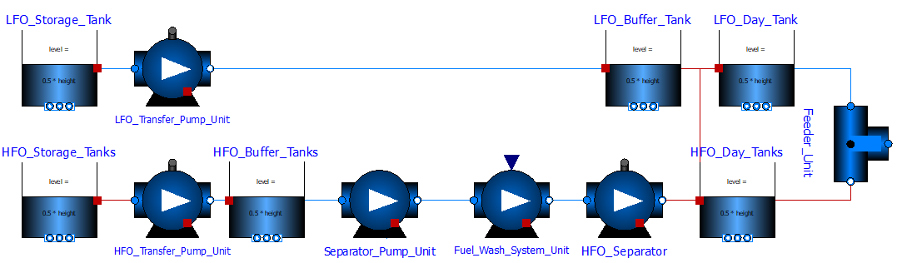

|  |  |  |
| --- | --- | --- |
| 1 | Fuel Decanting Shed  D:\UET\UET\Kohinoor Internhip\Photos\FUEL\DECANTING SHED\DSC_0000349.jpg D:\UET\UET\Kohinoor Internhip\Photos\FUEL\DECANTING SHED\DSC_0000321.jpg D:\UET\UET\Kohinoor Internhip\Photos\FUEL\TRANSPORT\DSC_0000286.jpg |  |
| 2 | HFO Storage Tanks  D:\UET\UET\Kohinoor Internhip\Photos\FUEL\STORAGE\DSC_0000285.jpg D:\UET\UET\Kohinoor Internhip\Photos\FUEL\STORAGE\DSC_0000327.jpg |  |
| 3 | Transfer Pump Unit  D:\UET\UET\Kohinoor Internhip\Photos\FUEL\PIPES\DSC_0000447.jpg D:\UET\UET\Kohinoor Internhip\Photos\FUEL\PIPES\DSC_0000416.jpg D:\UET\UET\Kohinoor Internhip\Photos\FUEL\PIPES\DSC_0000453.jpg |  |
| 4 | Fuel Wash System Unit  D:\UET\UET\Kohinoor Internhip\Photos\FUEL\WASHING UNIT\DSC_0000396.jpg D:\UET\UET\Kohinoor Internhip\Photos\FUEL\WASHING UNIT\DSC_0000393.jpg D:\UET\UET\Kohinoor Internhip\Photos\FUEL\WASHING UNIT\DSC_0000392.jpg |  |
| 5 | Buffer Tanks  D:\UET\UET\Kohinoor Internhip\Photos\FUEL\STORAGE\DSC_0000328.jpg D:\UET\UET\Kohinoor Internhip\Photos\FUEL\PIPES\DSC_0000451.jpg |  |
| 6 | Day Tanks  D:\UET\UET\Kohinoor Internhip\Photos\FUEL\STORAGE\DSC_0000289.jpg D:\UET\UET\Kohinoor Internhip\Photos\FUEL\PIPES\DSC_0000452.jpg D:\UET\UET\Kohinoor Internhip\Photos\FUEL\PIPES\DSC_0000421.jpg |  |

Booster System

Common Sludge Oil System

Common Engine Cooling System

Common Steam Turbine Cooling System

Common Water Treatment System

Steam Heating System

Starting Air System

DG-SET Lube Oil System

DG-SET Cooling System

DG-SET Exhaust Gas and Charge Air System